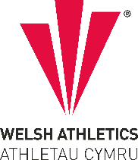

West Wales Regional Athletics Council

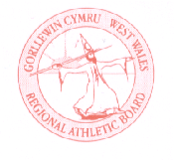
Minutes – West Wales Regional Athletics Council
Friday 18th October 2024
Microsoft Teams Meeting
__________________________________________________________________________________________
Present: Rob Campion Chairman
Nathan Jones Secretary
Les Cuthbert Treasurer
Andrew Jenkins Afan Nedd Tawe Schools Athletic Association
Lisa Campion Track & Field Committee Representative
Nigel Jones Officials Committee Representative (Endurance)
Owain Schiavone FMR Committee Representative
Dic Evans FMR Committee Representative
Gareth Harries Officials Secretary
Helen Williams Llanelli AAC
Jennifer Boyce Pembrokeshire Harriers

_______________________________________________________________________________________

Apologies: Neil Thomas
_______________________________________________________________________________________

Actions from Previous Meeting
West Wales Merchandise Shop – Polo shirt and hoodies for officials/officers have been distributed.
Wind Gauge and Replacement tent Bag – Purchased. Wind gauge with the starters kit
_______________________________________________________________________________________

- Discussion

- Welsh Inter-Regional Track & Field Championships 2025
West Wales are set to host the 2025 edition of the Inter Regional Championships in the region. 12th July is the date set possibly for Swansea or Carmarthen. Need to get feedback what the appetite is for the event, will the North support and attend, age groups involved. T& F Committee meeting next week.

- Welsh Inter-Regional 10K Championships held at Caerphilly 10K
Welsh Inter Regional 10km Championships which are being incorporated into the Caerphilly 10km. Teams of 6 Men & 6 Women with 5 to score will be selected on Tuesday 8th April 2025.

Selection will be based on performance attained in UK/Welsh Athletics licenced races between 1st November 2024 and 6th April 2025 inclusive.

- West Wales 10K & Half Marathon Championships
St Clears 10K Race hosted the 10K championships on Sunday 18th August with medals awarded across all age groups. Dale Half Marathon on Sunday 29th September was cancelled due to weather conditions. Planned to keep the same events next year.
TROTS paid for chip timing this year, West Wales plan to contribute half of the cost (approximately £250) towards this as the region is part of the event.

- Welsh Inter-Regional Cross Country Championships
At Newtown on Saturday 16th November on the same day as the Welsh Inter-Schools and Colleges Championships. Athletes selected will be notified, interest already coming in. West Wales Championships were incorporated into the Gwent League at Pembrey. Again this year, it clashes with the British & Irish Masters Cross Country International on the same day.

- West Wales Indoor Championships
Sunday 1st December – 200m, 300m and 400m
Sunday 5th January – 800m and 1500m
West Wales Championships in Swansea provisionally for Saturday 11th January (Jumps) and Saturday 15th February (Track/Shot) need to check with the University. Adding a photofinish / timekeeping course is a good idea as the track course went well in the summer.
- Possibility of having a West Wales 5K Championship race
Other regions hold a 5K championship. Limited events to look at, Carmarthen Mayor’s Race has a 5K annually but is not currently licensed. Nigel with endurance experience to see if there are suitable events.

- Discussion of I Run Wales and Clwb Run Wales Affiliation
Request to discuss from North Wales. No feedback to report from the region.

- YDL Selection
West Wales YDL athletes who give their availability in advance to the team manager (at least 2 weeks in advance) will get opportunity as part of the team.
As a league, rather than representative fixture every effort is made to accommodate as many athletes as possible. The proximity of league fixtures, other matches and numerous other variabilities effecting athletes, availability and timing of confirmation of ability, makes finalising the team composition an unattainable goal 2 weeks prior to each round. The council’s final decision was not to impose selection deadlines for league matches, however do acknowledge that everyone would like clarification of the team as soon as is practical.
Guest spaces are also available in the YDL. Under 17 athletes can now move up to compete in the under 20 age group across all events (new amendment changed from the 2023 season) so there are increased opportunities to the region’s athletes, in this case priority will be given to under 20’s first.
Athletes might not be entered in their preferred event each time, however every effort has continued to be made for athletes to take part in their main discipline when possible. As with league competitions, athletes tend to support generally in other disciplines too as part of the team element.

- Information – Reports

- General Council
Nothing to update.

- Track and Field Committee
The next meeting is next week.

- Officials Committee and Secretary
Update to follow from the officials committee. Availability forms for the indoor season have been emailed out to officials on the database by WA. Reminder that DBS checks are up to date.

- Road Running/Cross Country Committee
Nothing to update.

- FMR Committee
West Wales Mountain Championships at Hafod in May or Red Kite Challenge held in April, awaiting date availability.

- Welfare Officer
Nothing to update.
_______________________________________________________________________________________
- Financial Report (correct on Thursday 17th October)
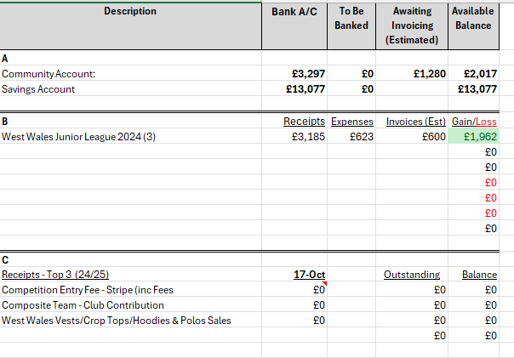
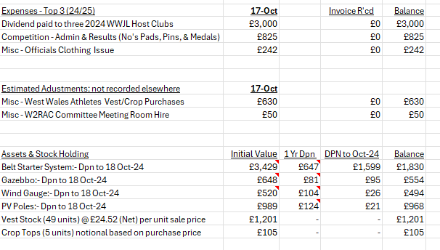
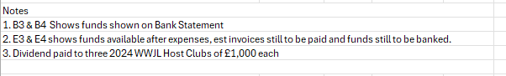

- AOB

Region sourcing its own medals - £750 received which is down on recent years. Existing stock to be used first.
Starter Kit is currently stored in Neath. Request to purchase proper case that it doesn’t get damaged, costs to be confirmed and updated.

- Date of Next Meeting Wednesday 11th December at 8:00pm (online)

